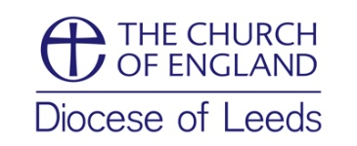

Leeds Diocesan Lay Training
Tutors’ Fees
2018/2019 Year

Stipendiary Clergy Full fee
Full 12 weeks course £75
Less than 12 weeks Pro rata full fee
Mileage Leeds Diocesan rate

Self-Supporting Clergy Fee
Meetings £20 per hour
Marking £20 per hour
Teaching £25 per hour
Mileage Nil

